**Requirements Implemented:**

**Requirement ID: Charts-1**

**Description:**

Improved overall appearance of the pie charts:

* Created a preset list of colors that work well together, improvement on the previous implementation of assigning colors at random
* Changed the outline of the pie chart from grey to black, looks sharper
* Moved the text which specifies amounts off the pie chart, now displayed after the label name

**Origin:**

Our group collectively was unhappy with the original appearance of the pie charts.

**Requirement Type:** Stretch

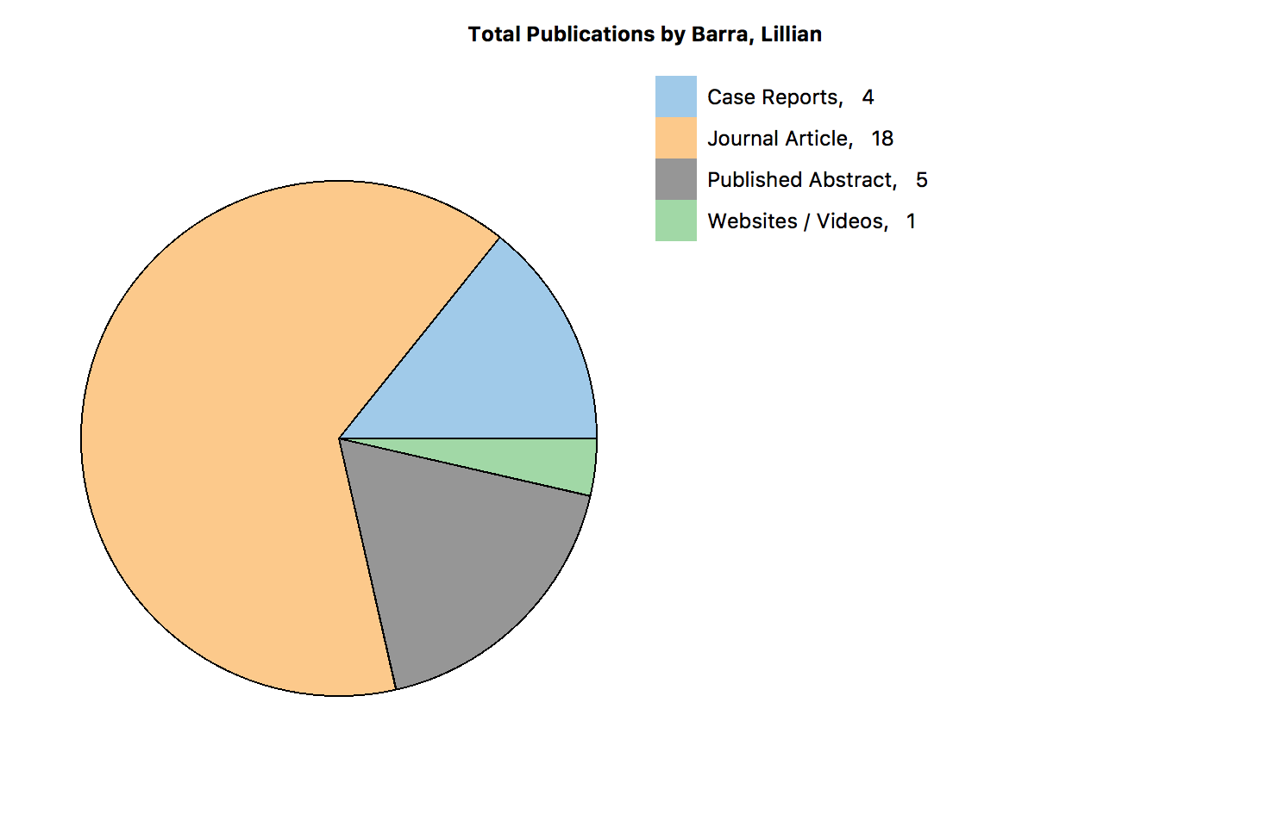

**Requirement ID: Charts-2**

**Description:**

Added an option for displaying a simple line graph. Displays the data in line graph form.

**Origin:**

Customer Specifications

**Requirement Type:** Mandatory

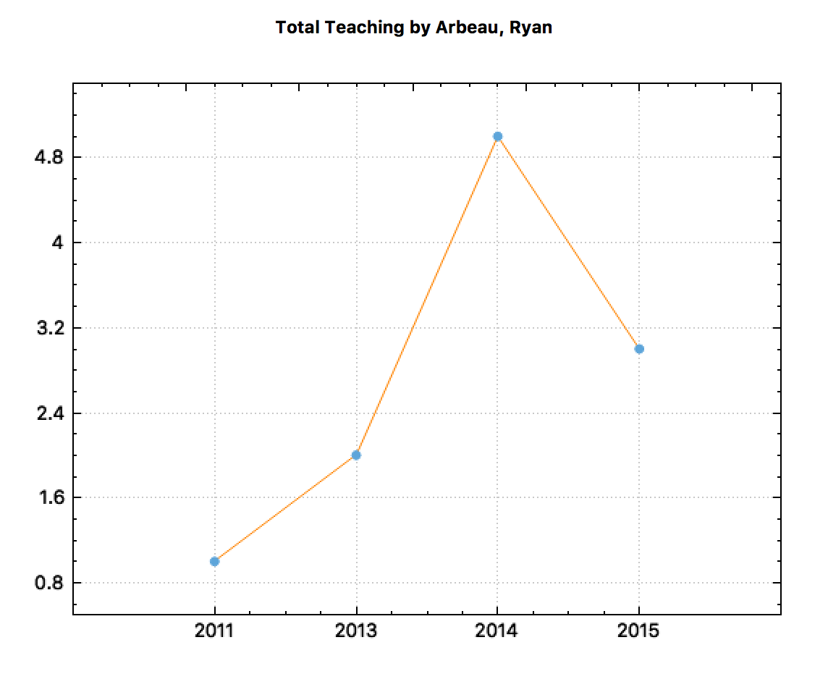

**Quick side note about all charts:** You can customize which data points are plotted on the graph by modifying the sort order.

So, for example if you wanted the graph to plot teaching for a specific person by the date like in the graph above. You would create a new sort that uses Name then the date like so:

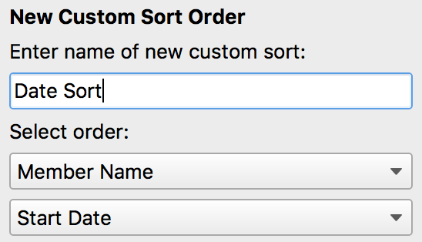

**Requirement ID: Charts-3**

**Description:**

Added an option for displaying a stacked bar char. Displays the data in a stacked bar chart form so one can easily compare the relative size of each data point.

**Origin:**

Customer Specifications

**Requirement Type:** Mandatory

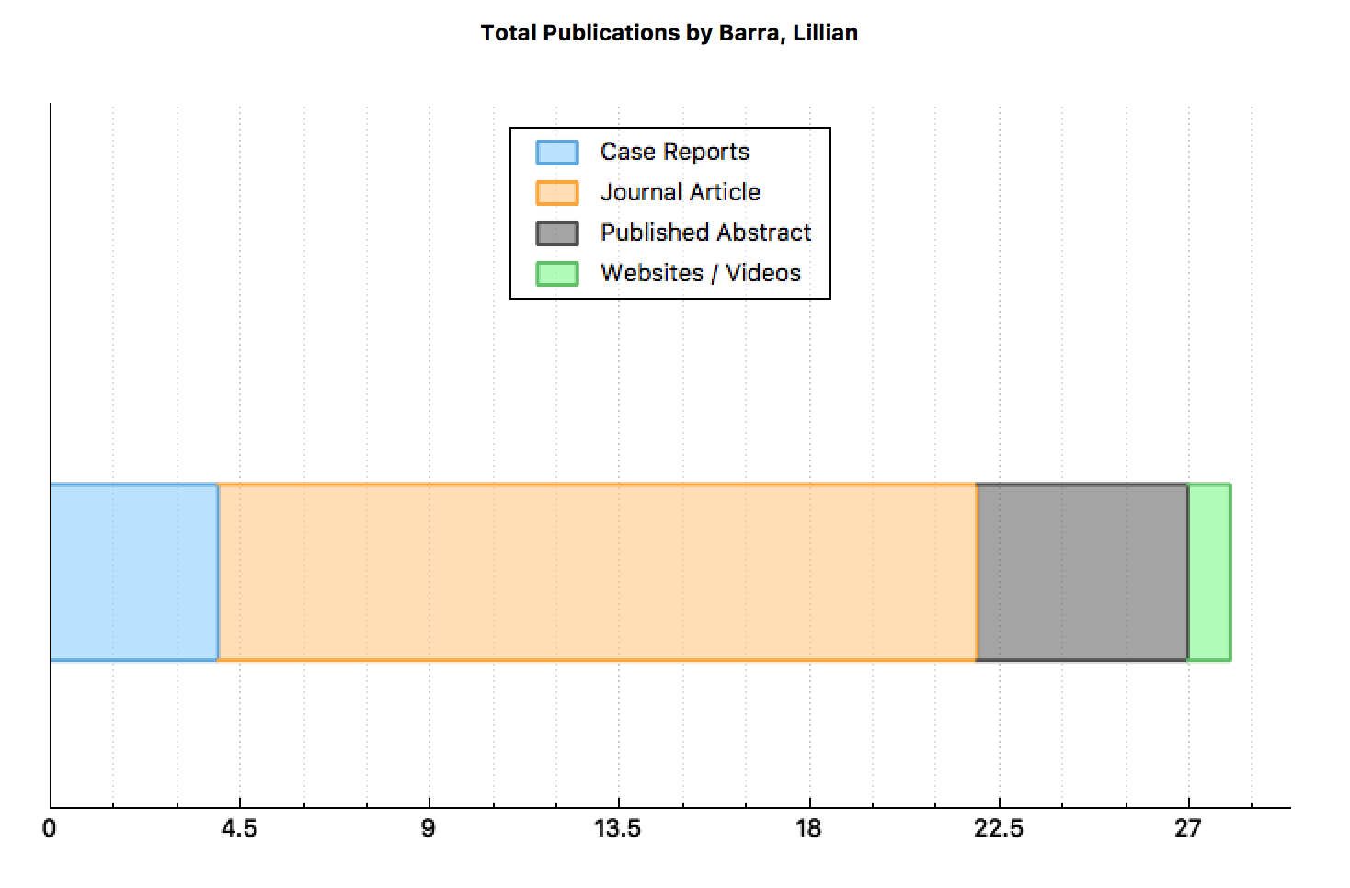

**Requirement ID: ErrorEdit-1**

**Description:**

Added a find next and find previous button for the error edit dialog. It also displays a count of the errors left to fill out.  
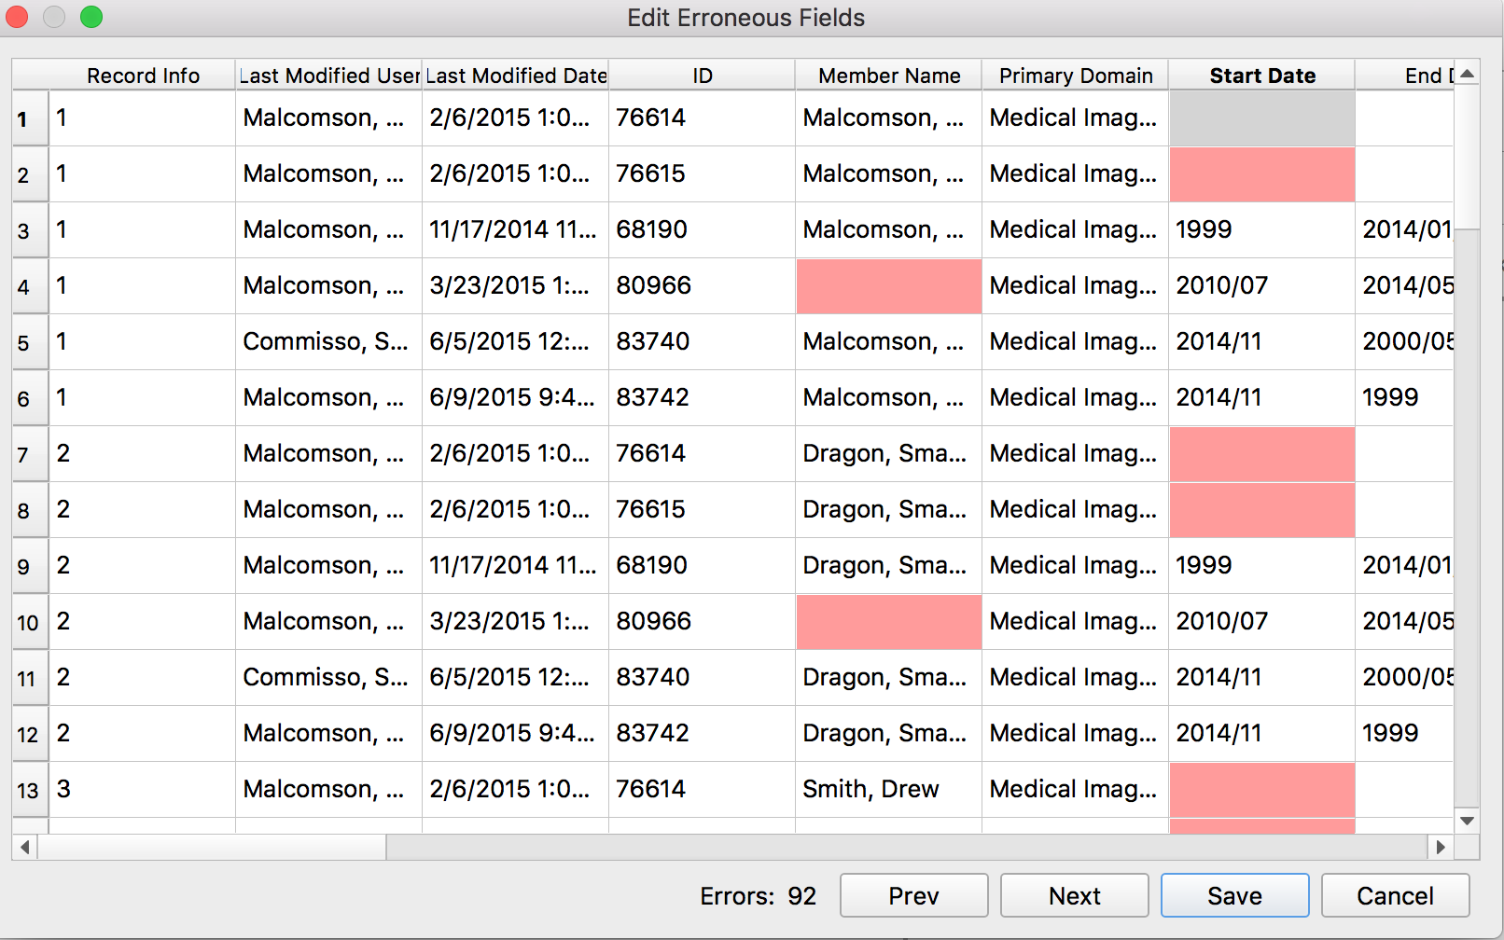

**Origin:**

Customer Specifications

**Requirement Type:** Mandatory

**Requirement ID: ErrorEdit-2**

**Description:**

Added the feature that when a data item is filled in it turns green to show that the cell has been filled out.  
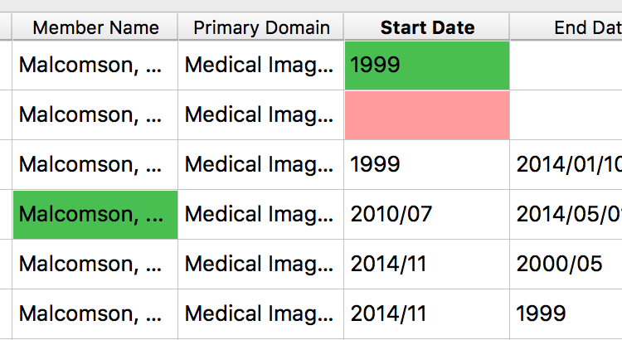

**Origin:**

Our group thought that it was hard to tell which fields have been filled in and which fields still need to be filled out.

**Requirement Type:** Mandatory

**Requirement ID: Sort-1**

**Description:**

Added a sort by division.

**Origin:**

Customer Specifications

**Requirement Type:** Mandatory

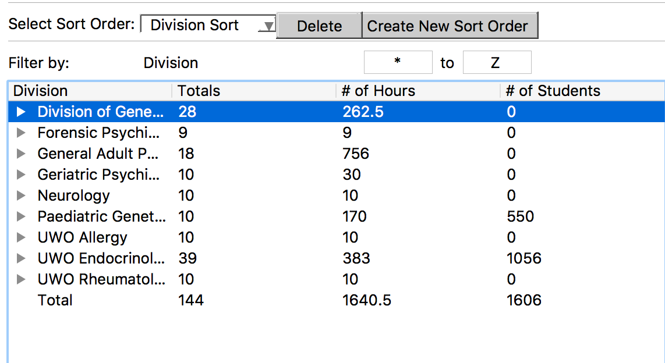

**Requirement ID: Sort-2**

**Description:**

Added the ability to change/modify an existing sort order.

**Origin:**

Customer Specifications

**Requirement Type:** Stretch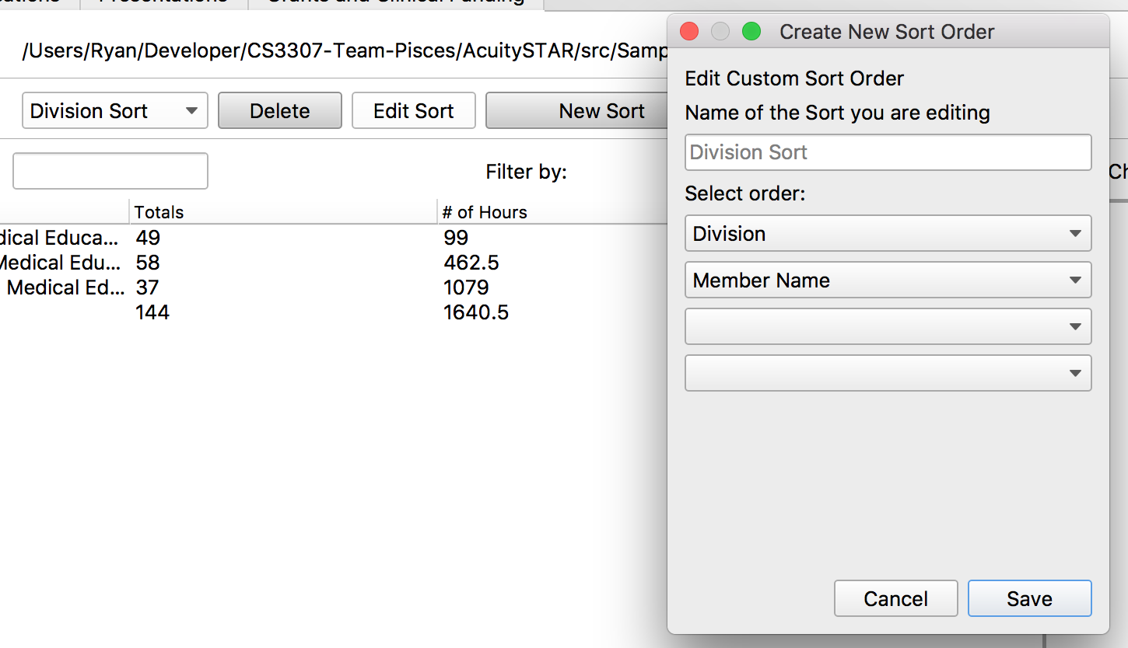

**Requirement ID: Sort-2**

**Description:**

Added the ability to sort by a user selected list

**Origin:**

Customer Specifications

**Requirement Type:** Mandatory

Press “User Select”

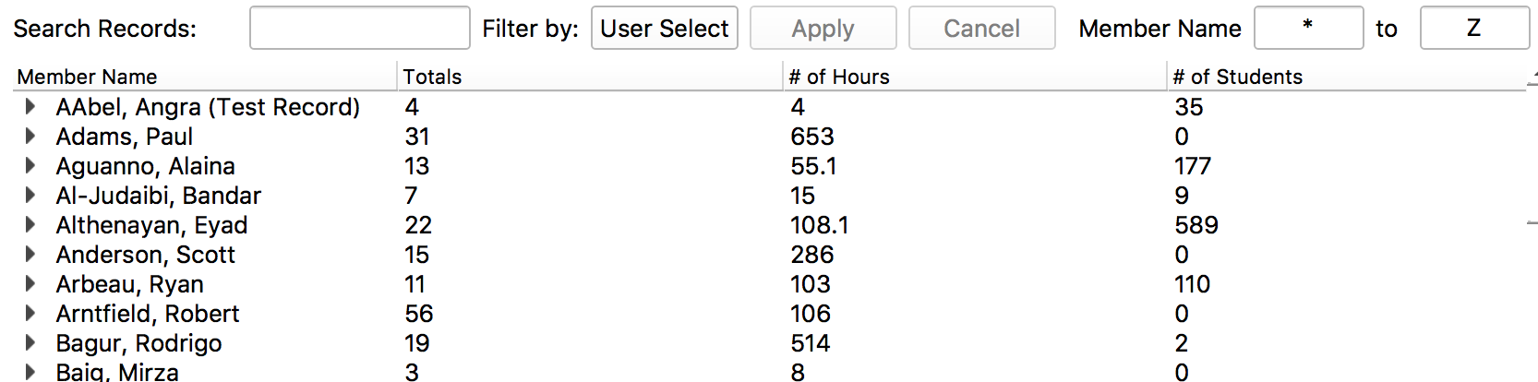

“Select your list”

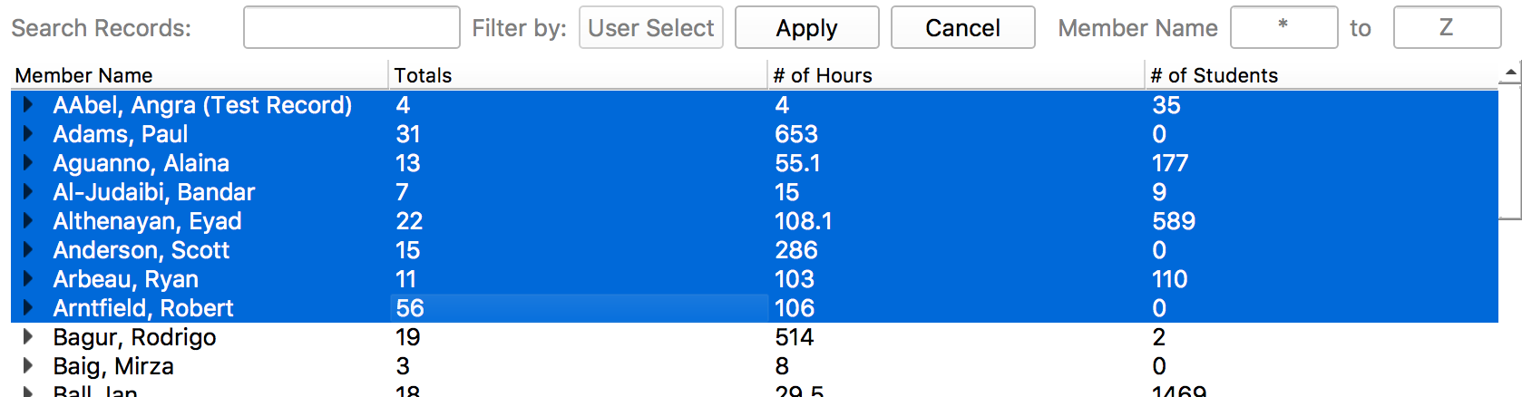

“Click Apply to filter list to only the names you had selected”

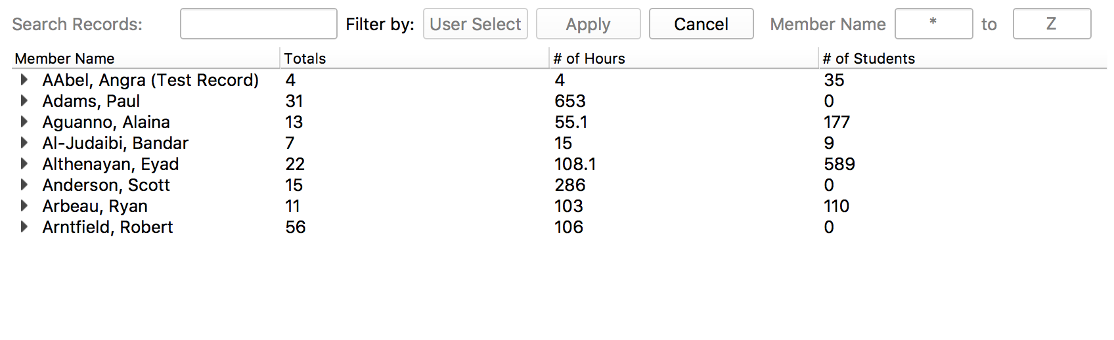

**Requirement ID: Search-1**

**Description:**

Added an advanced search feature to search through the data in the tree view.

**Origin:**

Customer Specifications

**Requirement Type:** Stretch

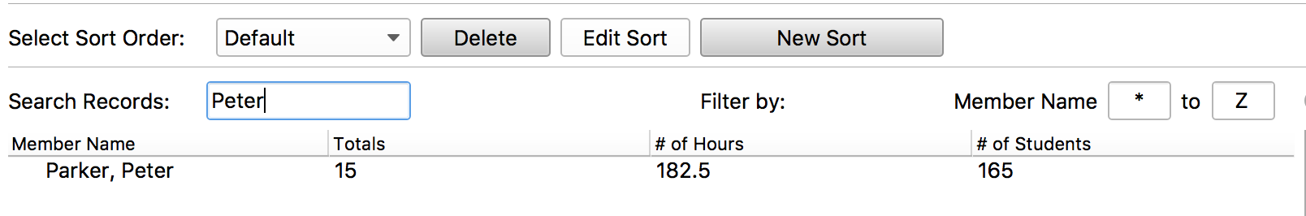

**Requirement ID: Drag&Drop-1**

**Description:**

Added the ability for a user to simply drag and drop a csv file into the application to load it.

**Origin:**

Our group found it a pain to have to use the file explorer every time we wanted to load a file and wanted to find a way to make loading files easier.

**Requirement Type:** Stretch

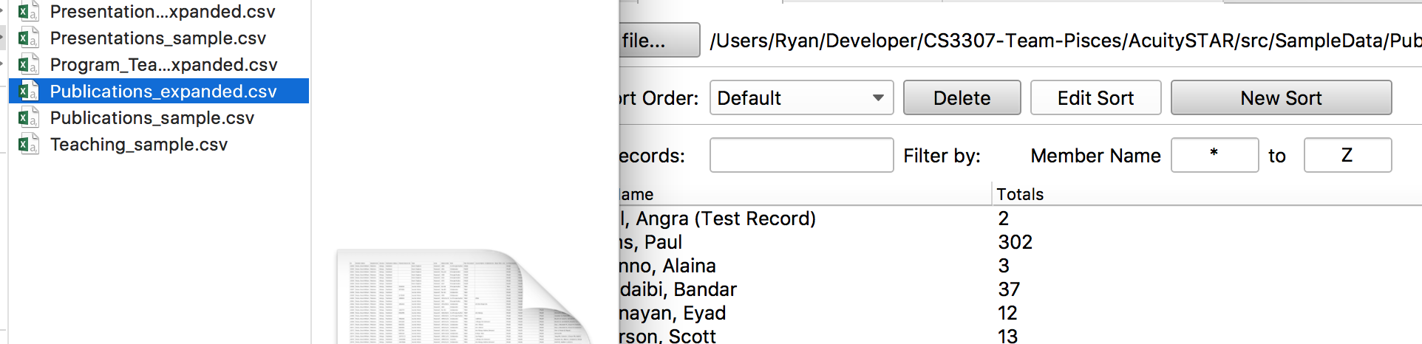

**Requirement ID: Save State-1**

**Description:**

Added a prompt to re-open the file the user was last working on and switches to the appropriate tab.

**Origin:**

Customer Specifications

**Requirement Type:** Manditory

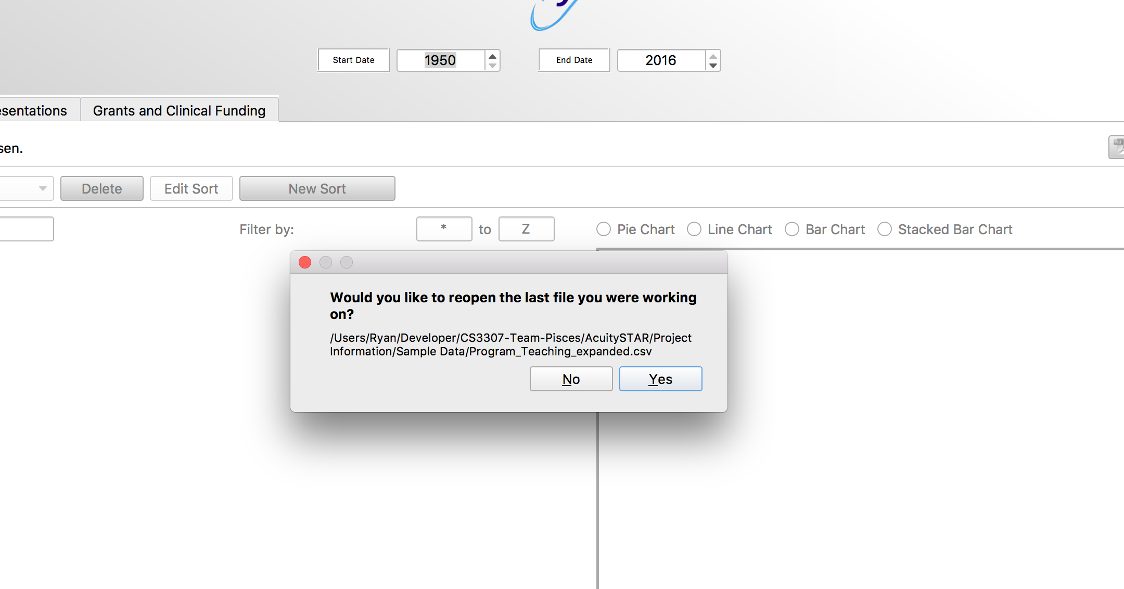

**Requirement ID: Keyboard Shortcut-1**

**Description:**

Added several keyboard shortcuts to make navigating the program easier.

* Control-P: Print Graphs
* Control-E: Export Graphs
* Control-L: Load a file
* Control-1/2/3/4 – Quick Switch between Teaching, Publications, Presentation and Grants tab

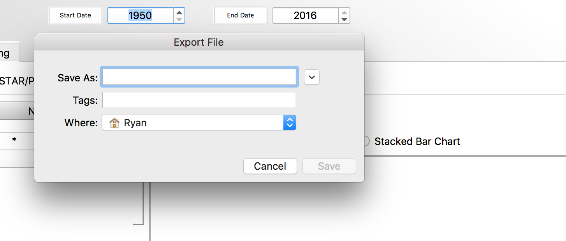

**Origin:**

Our group wanted to add a way for power users to be able to quickly navigate around our program.

**Requirement Type:** Stretch